

Test Plan for Order # HHSP23337004 – Standards Implementation And Testing Environment under BPA contract # HHSP233201200038B

**Prepared By:**

**Audacious Inquiry, LLC**

5523 Research Park Drive, Suite 370

Baltimore, MD 21228

301-560-6999

These data shall not be disclosed, duplicated or used outside the Government for other than evaluation purposes. This restriction does not limit the government’s right to use information contained in this data if it is obtained from other sources without restriction.

**Test Plan for SITE Phase 3**

**Order No:** HHSP23337004 **Contract No: HHSP233201200038B**

**ATTENTION:** Avinash Shanbhag

Jiuyi Hua

Matthew Rahn

Patricia Wright

**CLIENT:** HHS/ONC

**PROJECT TITLE:** Standards Implementation and Testing Environment.

**REPORTING PERIOD:** October 1, 2013 – December 31, 2013

**SCHEDULE CHANGE:**  Yes  No

**FUNDING CHANGE:**  Yes  No

**SCOPE OF REPORT:**

This report represents the required monthly project status report for the Ai team executing the Standards Implementation and Testing Environment task order for SITE Phase 3 implementation. The report contains a review of the work identified and accomplished during the reporting period, including a summary listing of task assignments completed, assignments in progress during the current period, any backlogged assignments, potential assignments, a high-level timeline, and a summary of performance statistics and service availability.

**COMMENTS:**

The program was started by the kick off meeting held on 9/4/2013.

**APPROVED BY: APPROVED BY:**

*Approval on file* _________ *Approval on file* _________

Nagesh Bashyam William Dyer

Chief Architect Project Manager

**APPROVED BY:**

*Approval on file* _________

Greg Farnum

Program Director

# Introduction

*The focus of the ONC SITE project is to enhance existing & support the new features that will* assist developers of Health Information Technology in their efforts to implement the standards required for certification of Electronic Health Record (EHR) technology, and in general, enable health information interoperability. This Test Plan describes the testing strategy and approach to QA testing and will be used to validate the quality of the product prior to release.

## QA/Test/Dev Environment Overview

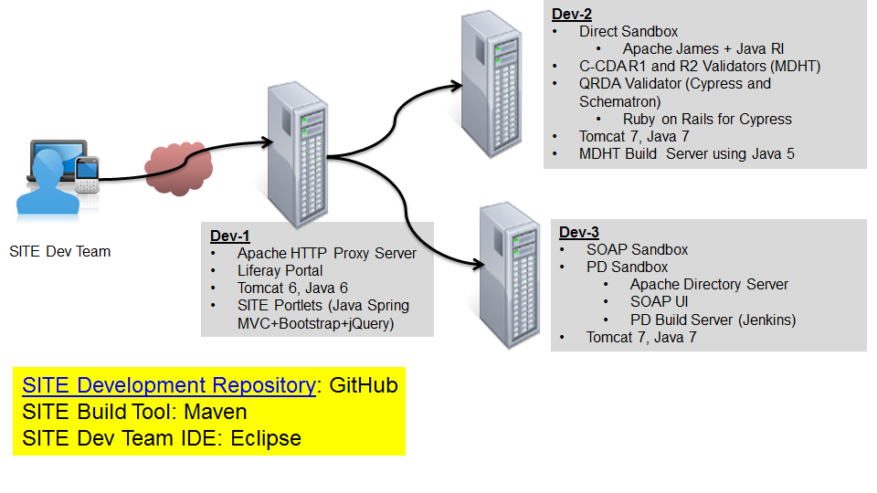

## Test Summary

Following features will be tested as a part of this test plan:

Existing Features:

* + Direct Sandbox
  + C-CDA Sandbox
  + Security Improvements
  + SITE Usability
  + SITE 508 Compliance
  + Metrics and Reporting
  + SDO Interactions
  + Moderator Activities

New Features:

* + Provider Directories
  + Quality Measures (QRDA)

## General SITE Activities

Test team will be responsible for following activities during SITE release 3.0:

* Attend weekly sprint meetings for SITE and create & update QA related tasks in JIRA and present progress on the tasks
* Test all the features listed in section 1.2 of this test plan and test overall SITE implementation
* Prepare and deliver the documentation as listed in section 1.3.5 of this test plan

### SITE Quality Measures Activities

* Requirements gathering on Quality Measures
* Test cases preparation for Quality Measures – Functional, non-functional, usability, navigation
* Test cases execution to test the implementation
* Reporting of defects found during the testing and maintenance of defect log
* Retesting of defects to follow upon fix and test team to update defect status to open/close.
* Regression tests will be performed as needed.

### SITE Provider Directories (PD) Activities

* Requirements gathering on Provider Directories
* Test cases preparation for Provider Directories – Functional, non-functional, usability, navigation
* Test cases execution to test the implementation
* Reporting of defects found during the testing and maintenance of defect log
* Retesting of defects will follow upon fix and test team will update defect status to open/close.
* Regression tests will be performed as needed.

### SITE C-CDA Activities

* Requirements gathering on C-CDA
* Test cases preparation for C-CDA – Functional, non-functional, usability, navigation
* Test cases execution to test the implementation
* Reporting of defects found during the testing and maintenance of defect log
* Retesting of defects will follow upon fix and test team will update defect status to open/close.
* Regression tests will be performed as needed.

### SITE Direct Sandbox Activities

* Requirements gathering on Direct Sandbox
* Test cases preparation for Direct Sandbox – Functional, non-functional, usability, navigation
* Test cases execution to test the implementation
* Reporting of defects found during the testing and maintenance of defect log
* Retesting of defects will follow upon fix and test team will update defect status to open/close.
* Regression tests will be performed as needed.

### Deliverables Submitted

* Test Plan
* Test case document
* Test data
* Checklist / Smoke Test to verify Production System
* Defect Report
* Known bugs going to production
* Additional notes deemed necessary to document (e.g. team decisions, etc.)

# Test Strategy

Following types of testing will be performed for SITE testing:

* Functional Testing
* Security Testing
* Stability Testing
* Regression Testing

508 Compliance testing will be performed on all the features listed in section 1.1 of this test plan and overall SITE implantation.

# Resources

### Test Tools

JIRA will be used to create user stories, report task progress and bug tracking.

Additional tools may be used to automate testing efforts.

# DEPENDENCIES/RISKS

### 508 Compliance Changes

* Need to manage the changes identified and plan to incorporate them incrementally
* Create test cases for 508 compliance testing

### Change Management

* Need to manage the changes identified and plan to incorporate them incrementally